ECON 443 Labor Market Analysis
Assignment #3
Due: 2005/7/19

1. Consider the conditions of work in perfume factories. In New York perfume factories, workers dislike the smell of perfume, while in California workers appreciate the smell of perfume, provided that the level does not climb above S*. (If it rises above S*, they start to dislike it.) Suppose that there is no cost for firms to reduce or eliminate the smell of perfume in perfume factories and assume that the workers have an alternative wage, W*. Please draw a diagram using isocost and indifference curves that depicts the situation. (The New York and California isocost curves are the same, but their indifference curves differ.) What level of perfume smell is there in the New York factories? In the California factories? Is there a wage differential between the California and New York workers?

2. A firm is considering the adoption of a plan in which it would pay employees less than their MRP_{L} early in their careers and more than their MRP_{L} late in their careers. For a typical worker at the firm MRP_{L} = 10 + .1T, where T = the number of years which the worker has been employed at the firm and MRP_{L} is measured in dollars per hour. The worker's wage per hour is W = 8 + .2T. Assume that this wage is high enough to attract workers from alternative jobs, that the discount rate for the firm is 0, and that the expected tenure of a typical worker is 35 years. If workers retire after 35 years, will this plan be profitable for the firm? Explain. For how many years will the firm "underpay" it workers?

ECON 443 Labor Market Analysis

Assignment #3
Due: 2005/7/19

Student Number: Name:

1. Answer: See the figure below. The California workers are paid exactly the same as the New York workers. This wage equals W*. The level of smell in California is S*; in New York it is 0.
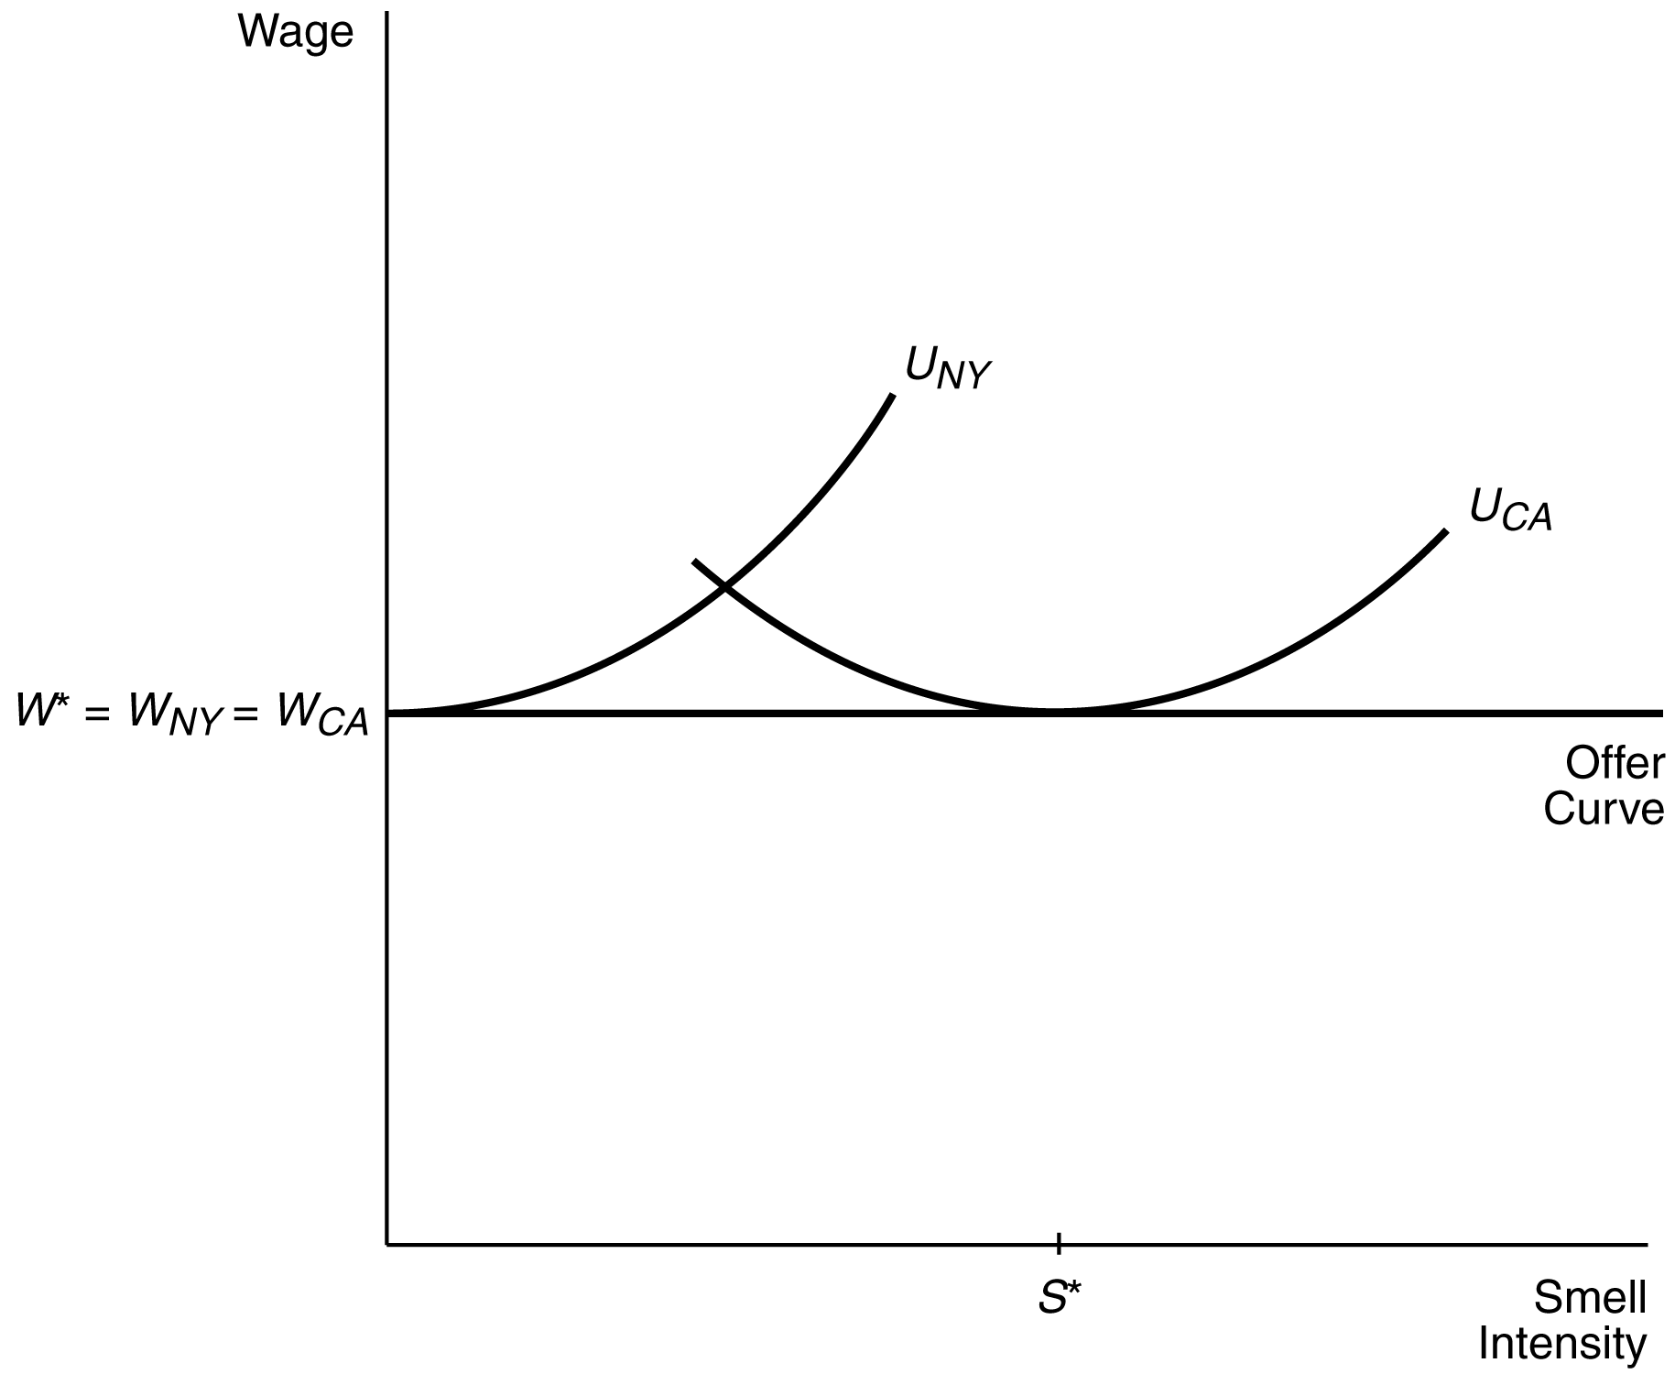
2. Answer: The graph shows the wage and MRP_{L} lines, which cross after 20 years. The firm will adopt the plan because it expects to profit from it -- the early underpayments exceed the later overpayments. (Because the discount rate is zero, we can find the present value of underpayments and overpayments by simply adding them up.) Triangle A (the initial underpayment) and triangle B (the later overpayment) are equal when T = 40 years. Triangle A exceeds triangle B if retirement comes before tenure equals 40 years.
