ECON 443 Labor Market Analysis
Assignment #1
Due: 2005/6/29

1. Suppose that the supply curve for school teachers is Ls = 20,000 + 350W and the demand curve for school teachers is Ld = 100,000 – 150W, where L = the number of teachers and W = the daily wage.
a. Plot the demand and supply curves.
b. What are the equilibrium wage and employment level in this market?
c. Now suppose that at any given wage 20,000 more workers are willing to work as school teachers. Plot the new supply curve and find the new wage and employment level. Why doesn't employment grow by 20,000?

2 The output of workers at a factory depends on the number of supervisors hired (see below). The factory sells its output for $.50 each, it hires 50 production workers at a wage of $100 per day, and needs to decide how many supervisors to hire. The daily wage of supervisors is $500 but output rises as more supervisors are hired, as shown below. How many supervisors should it hire?
Supervisors Output (units per day)
0 11,000
1 14,800
2 18,000
3 19,500
4 20,200
5. 20,600

ECON 443 Labor Market Analysis

Assignment #1
Due: 2005/6/29

Student Number: Name:

1. Answer: a. See the figure. Plot the Ld and Ls curves by solving for desired employment at given wage rates. If W = 500, for example, employers desire 25,000 workers (Ld = 100,000 – 150x500); if W = 400, they would desire 40,000. Since the equation above is for a straight line, drawing a line using these two points gives us the demand curve. Use the same procedure for the labor supply curve.
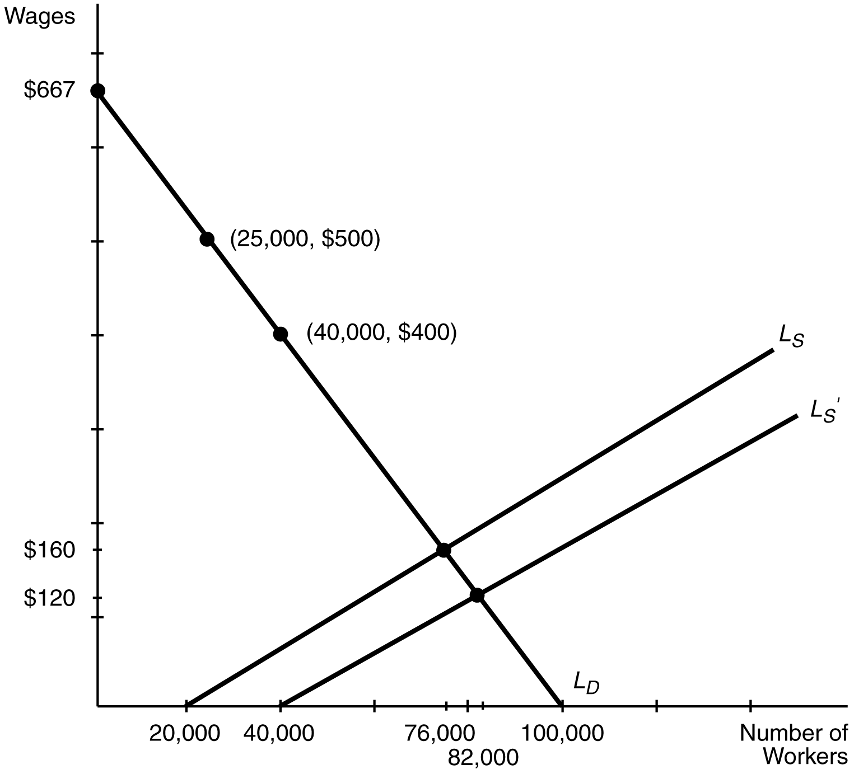
b. To find the equilibrium, solve for the wage at which the quantity of labor supplied equals the quantity of labor demanded: Ls = 20,000 + 350W = 100,000 – 150W = Ld. Solve for W by adding 150W to both sides and subtracting 20,000 from both sides to yield 500W = 80,000. Dividing both sides by 500 reveals that W = $160 per day. Plugging W = $160 into both the labor demand and supply equations shows that L = 76,000 schoolteachers.

c. The new labor supply curve is Ls' = 40,000 + 350W. Setting this equal to Ld and solving shows that W = $120 per day; L = 82,000 school teachers. Employment doesn't grow by 20,000 because the shift in the supply curve causes the wage to fall, which induces some teachers to drop out of the market.

2. Answer. The firm needs to compare the marginal cost to the marginal revenue product of hiring an additional supervisor. The marginal expense is always $500 for each extra supervisor. The marginal revenue is the number of additional units produced times the price of output.

Number of Supervisors ME MRP
1 $500 $.50x3800 = $1900
2 $500 $.50x3200 = $1600
3 $500 $.50x1500 = $750
4 $500 $.50x700 = $350
5 $500 $.50x400 = $200

The firm will hire three supervisors since the marginal revenue generated from hiring the third supervisor exceeds $500 but the marginal revenue generated from hiring the fourth supervisor is less than $500.

